STORING SENSITIVE
DATA
IN AUDIO
CHARAN N
19BCT017
DEPARTMENT OF ICT AND
COGNITIVE SYSTEMS
GUIDE: MR. SHANKAR R
1.INTRODUCTION

1.1AIM OF THE PROJECT:

We are of the belief that the easiest way to keep something from prying eyes is to place it right in front of the person looking for it and make it look as innocuous as possible.
Everyone has a taste for a certain kind of music. Hence, it is more than likely that the person will have that kind of music on the storage device of his computer. Also, it is quite common case where people share and transfer different music files to one another. If one were able to hide the message can be. Also, transfer of this message can be done quite conveniently without raising any eyebrows.
Our aim is to come up with a technique of hiding the message in the audio file in such a way, that there would be no perceivable changes in the in the audio file after the message insertion. At the same time, if the message that is to be hidden were encrypted, the level of security would be raised to quite a satisfactory level. Now, even if the hidden message were to be discovered the person trying to get the message would only be able to lay his hands on the encrypted message with no way of being able to decrypt it.

1.2 STEGANOGRAPHY IN AUDIO:

Data hiding in audio signals is especially challenging, because the Human Auditory System (HAS) operates over a wide dynamic range. The HAS perceives over a range of power greater than one billion to one and a range of frequencies greater than thousand to one. Sensitivity to additive random noise is also acute.
The perturbations in a sound file can be detected as low as one part in ten million which is 80dB below ambient level. However there are some ‘holes’ available. While the HAS has a large dynamic range, it has a fairly small differential range. As a result, loud sounds tend to mask out the quieter sounds.
Additionally, the HAS is unable to perceive absolute phase, only relative phase. Finally there are some environmental distortions so common as to be ignored by the listener in most cases.

1.2.1 Low-bit encoding:

Low-bit encoding is the one of the simplest way to embed data into other data structures. By replacing the least significant bit of each sampling point by a coded binary string, we can encode a large amount of data in an audio signal.

Ideally, the channel capacity is 1 kb per second (kbps) per 1 kilohertz(kHz), e.g., in a noiseless channel, the bit rate will be 8 kbps in an 8 kHz sampled sequence and 44 kbps in a 44kHz sampled sequence. In return for this large channel capacity, audible noise is introduced. The impact of this noise is a direct function of the content of the host signal, e.g., crowd noise during a live sports event would mask low-bit encoding noise that would be audible in a string quartet performance.

Adaptive data attenuation has been used to compensate this variation. The major advantage of this method is its poor immunity to manipulation. Encoded information can be destroyed by channel noise, re-sampling, etc., unless it is encoded using redundancy techniques.

In order to be robust, these techniques reduce the data rate which could result in the requirement of a host of higher magnitude, often by one to two orders of magnitude. In practice, this method is useful only in closed, digital-to-digital environments.
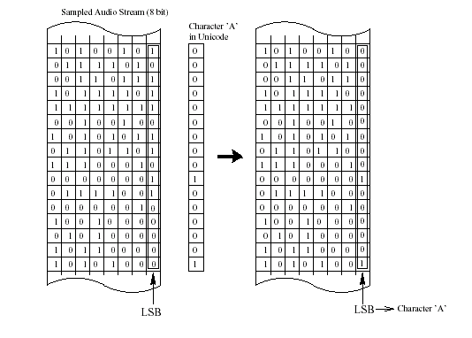

FIGURE 1.0

1.3 PROJECT DESCRIPTION:

Data hiding and extracting from an audio file is done in two main modules.
1) Embed module.
2) Extract module.

1.3.1 Embed module(To embed the text file into the audio file)

In this module, the first step is selecting an input audio file. The selection is made through opening a new dialog box and the path selected is displayed through a textbox. The second step is selecting an output audio file in which text data or a text file is embedded. The third step is choosing a text file or typing any text message for embedding. Fourth step is

Selecting a key file. In the fifth step what ever the files that we have selected are viewed and verification of the path is done. In the sixth process data is embedded in to the audio file using low bit encoding technique.After embedding the content both the audio files are played and a listener cannot find any difference between the audios.

1.3.2. Extract module(To extract the text file from the audio file)

In this module, the first step is the process of selecting the encrypted audio file. This is the file that a user has to extract information from the output audio. second process involved in selecting a new text file to display the embedded meassage.Symmetric encryption method is used here, so the key selected during the embedding process is used in decrypting the message.All the process done till now are displayed using a list box and finally the embedded message can be viewed with the help of a file or in a textbox.

2. SYSTEM STUDY

2.1 EXISTING SYSTEM:

Nowadays, several methods are used for communicating secret messages for defense purposes or in order to ensure the privacy of communication between two parties. So we go for hiding information in ways that prevent its detection.
Some of the methods used for privacy communication are the use of invisible links, covert channels are some of existing systems that are used to convey the messages.

2.2 PROPOSED SYSTEM:

The proposed system uses Audio file as a carrier medium which add another step in security. The objective of the newly proposed system is to create a system that makes it very difficult for an opponent to detect the existence of a secret message by encoding it in the carrier medium as a function of some secret key and that remains as the advantage of this system

2.3 FEASIBILITY STUDY:

The feasibility of the project is analyzed in this phase and business proposal is put forth with a very general plan for the project and some cost estimates. During system analysis the feasibility study of the proposed system is to be carried out. This is to ensure that the proposed system is not a burden to the company. For feasibility analysis, some understanding of the major requirements for the system is essential.

Three key considerations involved in the feasibility analysis are
*) ECONOMICAL FEASIBILITY
*) TECHNICAL FEASIBILITY
*) SOCIAL FEASIBILITY

2.3.1 ECONOMICAL FEASIBILITY:

This study is carried out to check the economic impact that the system will have on the organization. The amount of fund that the company can pour into the research and development of the system is limited. The expenditures must be justified. Thus the developed system as well within the budget and this was achieved because most of the technologies used are freely available. Only the customized products had to be purchased.

2.3.2 TECHNICAL FEASIBILITY:

This study is carried out to check the technical feasibility, that is, the technical requirements of the system. Any system developed must not have a high demand on the available technical resources. This will lead to high demands on the available technical resources. This will lead to high demands being placed on the client. The developed system must have a modest requirement, as only minimal or null changes are required for implementing this system.

2.3.3 SOCIAL FEASIBILITY:

The aspect of study is to check the level of acceptance of the system by the user. This includes the process of training the user to use the system efficiently. The user must not feel threatened by the system, instead must accept it as a necessity. The level of acceptance by the users solely depends on the methods that are employed to educate the user about the system and to make him familiar with it. His level of confidence must be raised so that he is also able to make some constructive criticism, which is welcomed, as he is the final user of the system.

3.SYSTEM SPECIFICATION

3.1 SOFTWARE SPECIFICATION:-

OPERATING SYSTEM :- Windows XP Professional
FRONT END :- Microsoft Visual Studio .Net 2003
CODING LANGUAGE :- C# .Net

3.2 HARDWARE SPECIFICATION:-

SYSTEM : Pentium III 700 Mhz
HARD DISK : 40 GB
FLOPPY DRIVE : 1.44 MB
MONITOR : 15 VGA colour monitor
MOUSE : Logitech.
RAM : 128 MB
KEYBOARD : 110 keys enhanced.

4. LANGUAGE SPECIFICATION

What is .NET?
When .NET was announced in late 1999, Microsoft positioned the technology as a platform for building and consuming Extensible Markup Language (XML) Web services. XML Web services allow any type of application, be it a Windows- or browser-based application running on any type of computer system, to consume data from any type of server over the Internet. The reason this idea is so great is the way in which the XML messages are transferred: over established standard protocols that exist today. Using protocols such as SOAP, HTTP, and SMTP, XML Web services make it possible to expose data over the wire with little or no modifications to your existing code.

Figure 1.1 presents a high-level overview of the .NET Framework and how XML Web services are positioned.

Figure 1.1. Stateless XML Web services model.
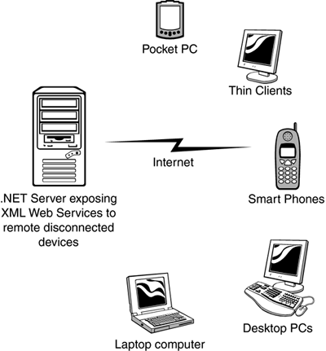
Since the initial announcement of the .NET Framework, it's taken on many new and different meanings to different people. To a developer, .NET means a great environment for creating robust distributed applications. To an IT manager, .NET means simpler deployment of applications to end users, tighter security, and simpler management. To a CTO or CIO, .NET means happier developers using state-of-the-art development technologies and a smaller bottom line. To understand why all these statements are true, you need to get a grip on what the .NET Framework consists of, and how it's truly a revolutionary step forward for application architecture, development, and deployment.

NET Framework
Now that you are familiar with the major goals of the .NET Framework, let's briefly examine its architecture. As you can see in Figure 1-2, the .NET Framework sits on top of the operating system, which can be a few different flavors of Windows and consists of a number of components .NET is essentially a system application that runs on Windows.
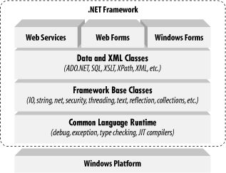
Conceptually, the CLR and the JVM are similar in that they are both runtime infrastructures that abstract the underlying platform differences. However, while the JVM officially supports only the Java language, the CLR supports any language that can be represented in its Common Intermediate Language (CIL). The JVM executes bytecode, so it can, in principle, support many languages, too. Unlike Java's bytecode, though, CIL is never interpreted. Another conceptual difference between the two infrastructures is that Java code runs on any platform with a JVM, whereas .NET code runs only on platforms that support the CLR.

In April, 2003, the International Organization for Standardization and the International Electrotechnical Committee (ISO/IEC) recognized a functional subset of the CLR, known as the Common Language Interface (CLI), as an international standard. This development, initiated by Microsoft and developed by ECMA International, a European standards organization, opens the way for third parties to implement their own versions of the CLR on other platforms, such as Linux or Mac OS X. For information on third-party and open source projects working to implement the ISO/IEC CLI and C# specifications
The layer on top of the CLR is a set of framework base classes. This set of classes is similar to the set of classes found in STL, MFC, ATL, or Java. These classes support rudimentary input and output functionality, string manipulation, security management, network communications, thread management, text management, reflection functionality, collections functionality, as well as other functions.
On top of the framework base classes is a set of classes that extend the base classes to support data management and XML manipulation. These classes, called ADO.NET, support persistent data management—data that is stored on backend databases. Alongside the data classes, the .NET Framework supports a number of classes to let you manipulate XML data and perform XML searching and XML translations.
Classes in three different technologies (including web services, Web Forms, and Windows Forms) extend the framework base classes and the data and XML classes. Web services include a number of classes that support the development of lightweight distributed components, which work even in the face of firewalls and NAT software. These components support plug-and-play across the Internet, because web services employ standard HTTP and SOAP.
Web Forms, the key technology behind ASP.NET, include a number of classes that allow you to rapidly develop web Graphical User Interface (GUI) applications. If you're currently developing web applications with Visual Interdev, you can think of Web Forms as a facility that allows you to develop web GUIs using the same drag-and-drop approach as if you were developing the GUIs in Visual Basic. Simply drag-and-drop controls onto your Web Form, double-click on a control, and write the code to respond to the associated event.
Windows Forms support a set of classes that allow you to develop native Windows GUI applications. You can think of these classes collectively as a much better version of the MFC in C++ because they support easier and more powerful GUI development and provide a common, consistent interface that can be used in all languages.

The Common Language Runtime
At the heart of the .NET Framework is the common language runtime. The common language runtime is responsible for providing the execution environment that code written in a .NET language runs under. The common language runtime can be compared to the Visual Basic 6 runtime, except that the common language runtime is designed to handle all .NET languages, not just one, as the Visual Basic 6 runtime did for Visual Basic 6. The following list describes some of the benefits the common language runtime gives you:
- Automatic memory management
- Cross-language debugging
- Cross-language exception handling
- Full support for component versioning
- Access to legacy COM components
- XCOPY deployment
- Robust security model
You might expect all those features, but this has never been possible using Microsoft development tools. Figure 1.3 shows where the common language runtime fits into the .NET Framework.

Figure 1.3. The common language runtime and the .NET Framework.
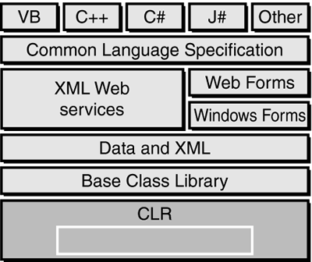

Note
Code written using a .NET language is known as managed code. Code that uses anything but the common language runtime is known as unmanaged code. The common language runtime provides a managed execution environment for .NET code, whereas the individual runtimes of non-.NET languages provide an unmanaged execution environment.

Inside the Common Language Runtime
The common language runtime enables code running in its execution environment to have features such as security, versioning, memory management and exception handling because of the way .NET code actually executes. When you compiled Visual Basic 6 forms applications, you had the ability to compile down to native node or p-code. Figure 1.4 should refresh your memory of what the Visual Basic 6 options dialog looked like.
Figure 1.4. Visual Basic 6 compiler options dialog.
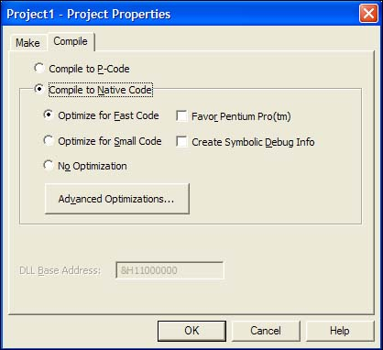
When you compile your applications in .NET, you aren't creating anything in native code. When you compile in .NET, you're converting your code—no matter what .NET language you're using—into an assembly made up of an intermediate language called Microsoft Intermediate Language (MSIL or just IL, for short). The IL contains all the information about your application, including methods, properties, events, types, exceptions, security objects, and so on, and it also includes metadata about what types in your code can or cannot be exposed to other applications. This was called a type library in Visual Basic 6 or an IDL (interface definition language) file in C++. In .NET, it's simply the metadata that the IL contains about your assembly.

Note
The file format for the IL is known as PE (portable executable) format, which is a standard format for processor-specific execution.

When a user or another component executes your code, a process occurs called just-in-time (JIT) compilation, and it's at this point that the IL is converted into the specific machine language of the processor it's executing on. This makes it very easy to port a .NET application to any type of operating system on any type of processor because the IL is simply waiting to be consumed by a JIT compiler.

Note
The first time an assembly is called in .NET, the JIT process occurs. Subsequent calls don't re-JIT the IL; the previously JITted IL remains in cache and is used over and over again. when you learn about Application Center Test, you also see how the warm-up time of the JIT process can affect application performance.

Understanding the process of compilation in .NET is very important because it makes clear how features such as cross-language debugging and exception handling are possible. You're not actually compiling to any machine-specific code—you're simply compiling down to an intermediate language that's the same for all .NET languages. The IL produced by J# .NET and C# looks just like the IL created by the Visual Basic .NET compiler. These instructions are the same, only how you type them in Visual Studio .NET is different, and the power of the common language runtime is apparent.
When the IL code is JITted into machine-specific language, it does so on an as-needed basis. If your assembly is 10MB and the user is only using a fraction of that 10MB, only the required IL and its dependencies are compiled to machine language. This makes for a very efficient execution process. But during this execution, how does the common language runtime make sure that the IL is correct? Because the compiler for each language creates its own IL, there must be a process that makes sure what's compiling won't corrupt the system. The process that validates the IL is known as verification. Figure 1.5 demonstrates the process the IL goes through before the code actually executes.

Figure 1.5. The JIT process and verification.

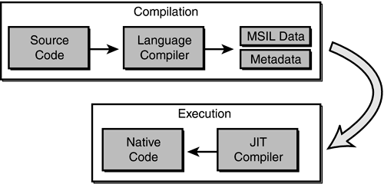
When code is JIT compiled, the common language runtime checks to make sure that the IL is correct. The rules that the common language runtime uses for verification are set forth in the Common Language Specification (CLS) and the Common Type System (CTS).

The .NET Framework Class Library
The second most important piece of the .NET Framework is the .NET Framework class library (FCL). As you've seen, the common language runtime handles the dirty work of actually running the code you write. But to write the code, you need a foundation of available classes to access the resources of the operating system, database server, or file server. The FCL is made up of a hierarchy of namespaces that expose classes, structures, interfaces, enumerations, and delegates that give you access to these resources.
The namespaces are logically defined by functionality. For example, the System.Data namespace contains all the functionality available to accessing databases. This namespace is further broken down into System.Data.SqlClient, which exposes functionality specific to SQL Server, and System.Data.OleDb, which exposes specific functionality for accessing OLEDB data sources. The bounds of a namespace aren't necessarily defined by specific assemblies within the FCL; rather, they're focused on functionality and logical grouping. In total, there are more than 20,000 classes in the FCL, all logically grouped in a hierarchical manner. Figure 1.8 shows where the FCL fits into the .NET Framework and the logical grouping of namespaces.

Figure 1.8. The .NET Framework class library.

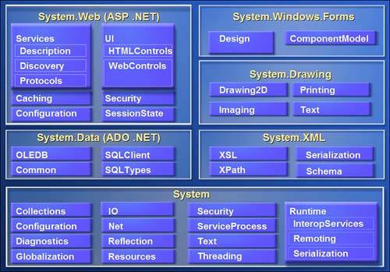
To use an FCL class in your application, you use the Imports statement in Visual Basic .NET or the using statement in C#. When you reference a namespace in Visual Basic .NET or C#, you also get the convenience of auto-complete and auto-list members when you access the objects' types using Visual Studio .NET. This makes it very easy to determine what types are available for each class in the namespace you're using. As you'll see over the next several weeks, it's very easy to start coding in Visual Studio .NET.
The Structure of a .NET Application
To understand how the common language runtime manages code execution, you must examine the structure of a .NET application. The primary unit of a .NET application is the assembly. An assembly is a self-describing collection of code, resources, and metadata. The assembly manifest contains information about what is contained within the assembly. The assembly manifest provides:
- Identity information, such as the assembly’s name and version number
- A list of all types exposed by the assembly
- A list of other assemblies required by the assembly
- A list of code access security instructions, including permissions required by the assembly and permissions to be denied the assembly
Each assembly has one and only one assembly manifest, and it contains all the description information for the assembly. However, the assembly manifest can be contained in its own file or within one of the assembly’s modules.
An assembly contains one or more modules. A module contains the code that makes up your application or library, and it contains metadata that describes that code. When you compile a project into an assembly, your code is converted from high-level code to IL. Because all managed code is first converted to IL code, applications written in different languages can easily interact. For example, one developer might write an application in Visual C# that accesses a DLL in Visual Basic .NET. Both resources will be converted to IL modules before being executed, thus avoiding any language-incompatibility issues.
Each module also contains a number of types. Types are templates that describe a set of data encapsulation and functionality. There are two kinds of types: reference types (classes) and value types (structures). These types are discussed in greater detail in Lesson 2 of this chapter. Each type is described to the common language runtime in the assembly manifest. A type can contain fields, properties, and methods, each of which should be related to a common functionality. For example, you might have a class that represents a bank account. It contains fields, properties, and methods related to the functions needed to implement a bank account. A field represents storage of a particular type of data. One field might store the name of an account holder, for example. Properties are similar to fields, but properties usually provide some kind of validation when data is set or retrieved. You might have a property that represents an account balance. When an attempt is made to change the value, the property can check to see if the attempted change is greater than a predetermined limit. If the value is greater than the limit, the property does not allow the change. Methods represent behavior, such as actions taken on data stored within the class or changes to the user interface. Continuing with the bank account example, you might have a Transfer method that transfers a balance from a checking account to a savings account, or an Alert method that warns users when their balances fall below a predetermined level.
Compilation and Execution of a .NET Application
When you compile a .NET application, it is not compiled to binary machine code; rather, it is converted to IL. This is the form that your deployed application takes—one or more assemblies consisting of executable files and DLL files in IL form. At least one of these assemblies will contain an executable file that has been designated as the entry point for the application.
When execution of your program begins, the first assembly is loaded into memory. At this point, the common language runtime examines the assembly manifest and determines the requirements to run the program. It examines security permissions requested by the assembly and compares them with the system’s security policy. If the system’s security policy does not allow the requested permissions, the application will not run. If the application passes the system’s security policy, the common language runtime executes the code. It creates a process for the application to run in and begins application execution. When execution starts, the first bit of code that needs to be executed is loaded into memory and compiled into native binary code from IL by the common language runtime’s Just-In-Time (JIT) compiler. Once compiled, the code is executed and stored in memory as native code. Thus, each portion of code is compiled only once when an application executes. Whenever program execution branches to code that has not yet run, the JIT compiler compiles it ahead of execution and stores it in memory as binary code. This way, application performance is maximized because only the parts of a program that are executed are compiled.
The .NET Framework base class library contains the base classes that provide many of the services and objects you need when writing your applications. The class library is organized into namespaces. A namespace is a logical grouping of types that perform related functions. For example, the System.Windows.Forms namespace contains all the types that make up Windows forms and the controls used in those forms.
Namespaces are logical groupings of related classes. The namespaces in the .NET base class library are organized hierarchically. The root of the .NET Framework is the System namespace. Other namespaces can be accessed with the period operator. A typical namespace construction appears as follows:
System
System.Data
System.Data.SQLClient
The first example refers to the System namespace. The second refers to the System.Data namespace. The third example refers to the System.Data.SQLClient namespace. Table 1.1 introduces some of the more commonly used .NET base class namespaces.
Table 1-1. Representative .NET Namespaces
Namespace | Description
System | This namespace is the root for many of the low-level types required by the .NET Framework. It is the root for primitive data types as well, and it is the root for all the other namespaces in the .NET base class library.
System.Collections | This namespace contains classes that represent a variety of different container types, such as ArrayList, SortedList, Queue, and Stack. You also can find abstract classes, such as CollectionBase, which are useful for implementing your own collection functionality.
System.ComponentModel | This namespace contains classes involved in component creation and containment, such as attributes, type converters, and license providers.
System.Data | This namespace contains classes required for database access and manipulations, as well as additional namespaces used for data access.
System.Data.Common | This namespace contains a set of classes that are shared by the .NET managed data providers.
System.Data.OleDb | This namespace contains classes that make up the managed data provider for OLE DB data access.
System.Data.SQLClient | This namespace contains classes that are optimized for interacting with Microsoft SQL Server.
System.Drawing | This namespace exposes GDI+ functionality and provides classes that facilitate graphics rendering.
System.IO | In this namespace, you will find types for handling file system I/O.
System.Math | This namespace is home to common mathematics functions such as extracting roots and trigonometry.
System.Reflection | This namespace provides support for obtaining information and dynamic creation of types at runtime.
System.Security | This namespace is home to types dealing with permissions, cryptography, and code access security.
System.Threading | This namespace contains classes that facilitate the implementation of multithreaded applications.
System.Windows.Forms | This namespace contains types involved in creating standard Windows applications. Classes that represent forms and controls reside here as well.
The namespace names are self-descriptive by design. Straightforward names make the .NET Framework easy to use and allow you to rapidly familiarize yourself with its contents.
Introduction to Object-Oriented Programming
Programming in the .NET Framework environment is done with objects. Objects are programmatic constructs that represent packages of related data and functionality. Objects are self-contained and expose specific functionality to the rest of the application environment without detailing the inner workings of the object itself. Objects are created from a template called a class. The .NET base class library provides a set of classes from which you can create objects in your applications. You also can use the Microsoft Visual Studio programming environment to create your own classes. This lesson introduces you to the concepts associated with object-oriented programming.
Objects, Members, and Abstraction
An object is a programmatic construct that represents something. In the real world, objects are cars, bicycles, laptop computers, and so on. Each of these items exposes specific functionality and has specific properties. In your application, an object might be a form, a control such as a button, a database connection, or any of a number of other constructs. Each object is a complete functional unit, and contains all of the data and exposes all of the functionality required to fulfill its purpose. The ability of programmatic objects to represent real-world objects is called abstraction.
Classes Are Templates for Objects
Classes were discussed in Chapter 1 and represent user-defined reference types. Classes can be thought of as blueprints for objects: they define all of the members of an object, define the behavior of an object, and set initial values for data when appropriate. When a class is instantiated, an in-memory instance of that class is created. This instance is called an object. To review, a class is instantiated using the New (new) keyword as follows:
Visual Basic .NET
' Declares a variable of the Widget type
Dim myWidget As Widget
' Instantiates a new Widget object and assigns it to the myWidget
' variable
myWidget = New Widget()
When an instance of a class is created, a copy of the instance data defined by that class is created in memory and assigned to the reference variable. Individual instances of a class are independent of one another and represent separate programmatic constructs. There is generally no limit to how many copies of a single class can be instantiated at any time. To use a real-world analogy, if a car is an object, the plans for the car are the class. The plans can be used to make any number of cars, and changes to a single car do not, for the most part, affect any other cars.
Objects and Members
Objects are composed of members. Members are properties, fields, methods, and events, and they represent the data and functionality that comprise the object. Fields and properties represent data members of an object. Methods are actions the object can perform, and events are notifications an object receives from or sends to other objects when activity happens in the application.
To continue with the real-world example of a car, consider that a Car object has fields and properties, such as Color, Make, Model, Age, GasLevel, and so on. These are the data that describe the state of the object. A Car object might also expose several methods, such as Accelerate, ShiftGears, or Turn. The methods represent behaviors the object can execute. And events represent notifications. For example, a Car object might receive an EngineOverheating event from its Engine object, or it might raise a Crash event when interacting with a Tree object.
Object Models
Simple objects might consist of only a few properties, methods, and perhaps an event or two. More complex objects might require numerous properties and methods and possibly even subordinate objects. Objects can contain and expose other objects as members. For example, the TextBox control exposes a Font property, which consists of a Font object. Similarly, every instance of the Form class contains and exposes a Controls collection that comprises all of the controls contained by the form. The object model defines the hierarchy of contained objects that form the structure of an object.
An object model is a hierarchical organization of subordinate objects contained and exposed within a main object. To illustrate, let’s revisit the example of a car as an object. A car is a single object, but it also consists of subordinate objects. A Car object might contain an Engine object, four Wheel objects, a Transmission object, and so on. The composition of these subordinate objects directly affects how the Car object functions as a whole. For example, if the Cylinders property of the Engine subordinate object is equal to 4, the Car will behave differently than a Car whose Engine has a Cylinders property value of 8. Contained objects can have subordinate objects of their own. For example, the contained Engine object might contain several SparkPlug objects.
Encapsulation
Encapsulation is the concept that implementation of an object is independent of its interface. Put another way, an application interacts with an object through its interface, which consists of its public properties and methods. As long as this interface remains constant, the application can continue to interact with the component, even if implementation of the interface was completely rewritten between versions.
Objects should only interact with other objects through their public methods and properties. Thus, objects should contain all of the data they require, as well as all of the functionality that works with that data. The internal data of an object should never be exposed in the interface; thus, fields rarely should be Public (public).
Returning to the Car example. If a Car object interacts with a Driver object, the Car interface might consist of a GoForward method, a GoBackward method, and a Stop method. This is all the information that the Driver needs to interact with the Car. The Car might contain an Engine object, for example, but the Driver doesn’t need to know about the Engine object—all the Driver cares about is that the methods can be called and that they return the appropriate values. Thus, if one Engine object is exchanged for another, it makes no difference to the Driver as long as the interface continues to function correctly.
Polymorphism
Polymorphism is the ability of different classes to provide different implementations of the same public interfaces. In other words, polymorphism allows methods and properties of an object to be called without regard for the particular implementation of those members. For example, a Driver object can interact with a Car object through the Car public interface. If another object, such as a Truck object or a SportsCar object, exposes the same public interface, the Driver object can interact with them without regard to the specific implementation of that interface. There are two principal ways through which polymorphism can be provided: interface polymorphism and inheritance polymorphism.
Interface Polymorphism
An interface is a contract for behavior. Essentially, it defines the members a class should implement, but states nothing at all about the details of that implementation. An object can implement many different interfaces, and many diverse classes can implement the same interface. All objects implementing the same interface are capable of interacting with other objects through that interface. For example, the Car object in the previous examples might implement the IDrivable interface (by convention, interfaces usually begin with I), which specifies the GoForward, GoBackward, and Halt methods. Other classes, such as Truck, Forklift, or Boat might implement this interface and thus are able to interact with the Driver object. The Driver object is unaware of which interface implementation it is interacting with; it is only aware of the interface itself. Interface polymorphism is discussed in detail in Lesson 3.
Inheritance Polymorphism

Inheritance allows you to incorporate the functionality of a previously defined class into a new class and implement different members as needed. A class that inherits another class is said to derive from that class, or to inherit from that class. A class can directly inherit from only one class, which is called the base class. The new class has the same members as the base class, and additional members can be added as needed. Additionally, the implementation of base members can be changed in the new class by overriding the base class implementation. Inherited classes retain all the characteristics of the base class and can interact with other objects as though they were instances of the base class. For example, if the Car class is the base class, a derived class might be SportsCar. The SportsCar class might be the base class for another derived class, the ConvertibleSportsCar. Each newly derived class might implement additional members, but the functionality defined in the original Car class is retained. Inheritance polymorphism

Microsoft Visual Basic.Net
With its release for the .NET platform, the Visual Basic language has undergone dramatic changes.
For example:
• The language itself is now fully object-oriented.
• Applications and components written in Visual Basic .NET have full access to the .NET Framework, an extensive class library that provides system and application services.
• All applications developed using Visual Basic .NET run within a managed runtime environment, the .NET common language runtime.

Visual Basic .NET is the next generation of Visual Basic, but it is also a significant departure from previous generations. Experienced Visual Basic 6 developers will feel comfortable with Visual Basic .NET code and will recognize most of its constructs. However, Microsoft has made some changes to make Visual Basic .NET a better language and an equal player in the .NET world. These include such additions as a Class keyword for defining classes and an Inherits keyword for object inheritance, among others. Visual Basic 6 code can't be compiled by the Visual Basic .NET compiler without significant modification. The good news is that Microsoft has provided a migration tool to handle the task.

CHAPTER 5

AUDIO FILE FORMAT:

An audio format is a medium for storing sound and music.It is a container format for storing audio data on a computer system. There are numerous file formats for storing audio files.
The general approach towards storing digital audio formats is to sample the audio voltage (corresponding to a certain position in the membrane of a speaker) in regular intervals (e.g. 44,100 times per second for CD audio or 48,000 or 96,000 times per second for DVD video) and store the value with a certain resolution (e.g. 16 bits per sample in CD audio). Therefore sample rate, resolution and number of channels are key parameters in audio file formats.

5.1TYPES OF FORMATS:
There are three major groups of audio file formats:
1) Common formats, such as WAV, AIFF and AU.
2) Formats with lossless compression, such as FLAC, Monkey’s Audio (filename extensionAPE), WavPack, Shorten, TTA, Apple Lossless,and lossless Windows Media Audio(WMA).
3) Formats with lossy compression, such as MP3, Vorbis, lossy Windows Media Audio(WMA) and AAC.
WAV is a flexible file format designed to store more or less any combination of sampling rates or bitrates. This makes it an adequate file format for storing and archiving an original recording.

5.2WAV FORMAT:
WAV (or WAVE), short for Waveform audio format, is a Microsoft and IBM audio fileformat standard for storing audio on PCs . It is a variant of the RIFF bitstream format method for storing data in "chunks".
A WAVE file is often just a RIFF file with a single "WAVE" chunk which consists of two sub-chunks -- a "fmt " chunk specifying the data format and a "data" chunk containing the actual sample data.

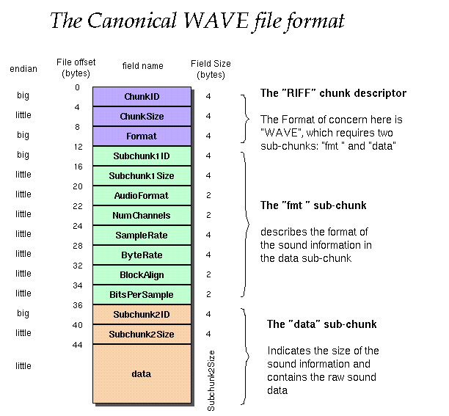 FIGURE 1.1

The canonical WAVE format starts with the RIFF header:

0 - 4 ChunkID Contains the letters "RIFF" in ASCII form

4 - 4 ChunkSize 36 + SubChunk2Size, or more precisely:
4 + (8 + SubChunk1Size) + (8 + SubChunk2Size)
This is the size of the rest of the chunk
following this number. This is the size of the
entire file in bytes minus 8 bytes for the
two fields not included in this count:
ChunkID and ChunkSize.
8 - 4 Format Contains the letters "WAVE"

The "WAVE" format consists of two subchunks: "fmt " and "data":
The "fmt " subchunk describes the sound data's format:

12 - 4 Subchunk1ID Contains the letters "fmt "

16 - 4 Subchunk1Size 16 for PCM. This is the size of the
rest of the Subchunk which follows this
number.
20 - 2 AudioFormat PCM = 1 (i.e. Linear quantization)
Values other than 1 indicate some
form of compression.
22 - 2 NumChannels Mono = 1, Stereo = 2, etc.
24 - 4 SampleRate 8000, 44100, etc.
28 - 4 ByteRate = SampleRate * NoChannels * BitsPerSample/8
32 - 2 BlockAlign = NumChannels * BitsPerSample/8
The number of bytes for one sample including
all channels.
34 - 2 BitsPerSample 8 bits = 8, 16 bits = 16, etc.

The "data" subchunk contains the size of the data and the actual sound:

36 - 4 Subchunk2ID Contains the letters "data"
40 - 4 Subchunk2Size = NoSamples * NoChannels* BitsPerSample/8
This is the number of bytes in the data.
You can also think of this as the size
of the read of the subchunk following this
number.
44 * Data The actual sound data.

As an example, here are the opening 72 bytes of a WAVE file with bytes shown as hexadecimal numbers:
52 49 46 46 24 08 00 00 57 41 56 45 66 6d 74 20 10 00 00 00 01 00 02 00
22 56 00 00 88 58 01 00 04 00 10 00 64 61 74 61 00 08 00 00 00 00 00 00
24 17 1e f3 3c 13 3c 14 16 f9 18 f9 34 e7 23 a6 3c f2 24 f2 11 ce 1a 0d

Here is the interpretation of these bytes as a WAVE soundfile:

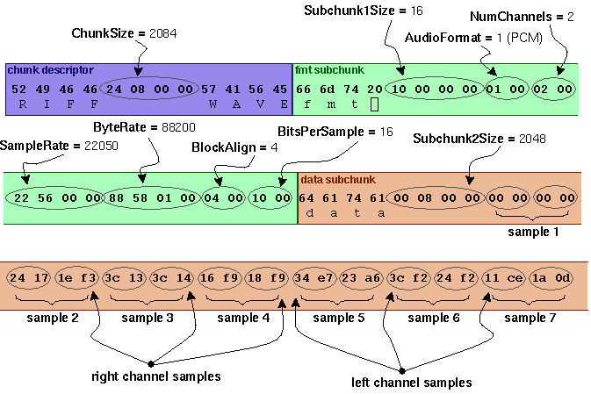

FIGURE 1.2

Though a WAV file can hold compressed audio, the most common WAV format contains uncompressed audio in the pulse-code modulation (PCM) format. PCM audio is the standard audio file format for CDs at 44,100 samples per second, 16 bits per sample. Since PCM uses an uncompressed, lossless storage method, which keeps all the samples of an audio track, professional users or audio experts may use the WAV format for maximum audio quality. WAV audio can also be edited and manipulated with relative ease using software.
The usage of the WAV format has more to do with its familiarity, its simplicity and simple structure, which is heavily based on the IFF file format. Because of this, it continues to enjoy widespread use with a variety of software applications.

Limitations:
The WAV format is limited to files that are less than 4 GiB in size, due to its use of a 32 bit unsigned integer to record the file size header (some programs limit the file size to 2 GiB). It is sometimes necessary to go over this limit, especially when higher sampling rates or bit resolutions are required. The W64 format was therefore created for use in Sound Forge. Its 64-bit header allows for much longer recording times.

CHAPTER 6

SYSTEM DESIGN:

6.1DATA FLOW DIAGRAM:

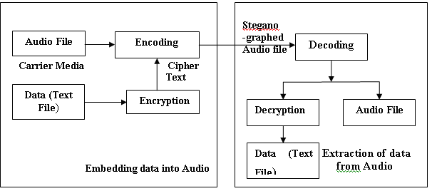

FIGURE 1.3

6.2USECASE DIAGRAM1: (EMBEDDING MODULE):

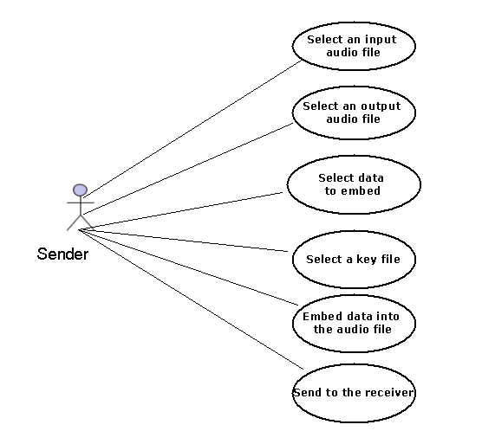

FIGURE 1.4

6.3USECASEDIAGRAM2: (EXTRACTION MODULE):

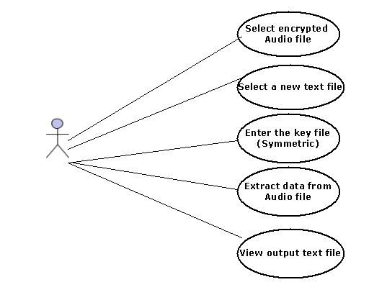

FIGURE1.5

6.4 CLASS DIAGRAM:

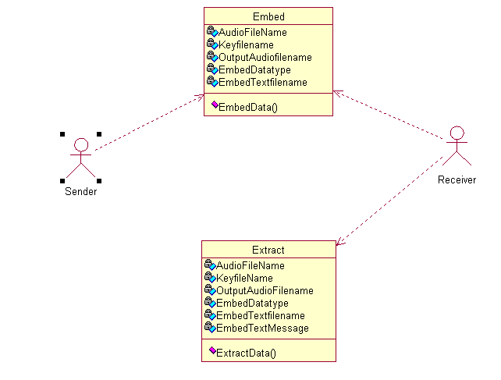

FIGURE 1.6

7.3 FUTURE ENHANCEMENTS:

* Can be sent through the network, and that can be extracted at the other
end.

* Support for other audio formats such as (wav, mp3) can easily be added
which needs additional sound encoding/decoding method to be
implemented

CHAPTER 8

SYSTEM TESTING :

Testing is the process of executing the program with the intent of finding errors. During testing, the program to be tested is executed with a set of test cases and the output of the program for the test cases is evaluated to determine the program is performing as it is expected. Error is the testing fundamental and is defined as the difference between the actual output of a software and a correct output i.e., difference between the actual and ideal testing is usually relied upon to detect these faults in the coding phase for this, different levels of testing are used which performs different tasks and aim to the test different aspects of the system.
8.1 GOALS OF TESTING:

The famous statement by Dijkstra (in Dahl et al. 1972) is a perfect synthesis of the goals of the testing. If the results delivered by the system are different from the expected ones in just one case, in this unequally shows that the system is incorrect: by contrast, a correct behavior of the system on a finite number of cases does not guarantee correctness in the general case. For instance, we could have built a program that behaves properly for even integer numbers but not odd numbers. Clearly, any number of tests with even input values will face to show the error.
Testing should be based on sound and systematic techniques so that, after testing, we may have a better understanding of the product’s reliability.
Testing should help locate errors, not just detect their presence. The result of testing should not be viewed as simply providing a Boolean answer to the question of whether the software works properly or not.
Tests should be organized in a way that helps to isolate errors. This information can then be used in debugging.
Testing should be repeatable, i.e., tests should be arranged in such a way that separating the same experiment-supplying the same input data to the same piece of code – produces the same results.
Finally testing should be accurate – this will increase the reliability of testing. Here we should observe that the accuracy of the testing activity depends on the level of precision and may be even formality of software specifications.

8.2TYPES OF TESTING:

Functional Testing

Here the structure of the program is not considered. Only the test cases are decided solely on the basis of the requirements or specification of the program or module and the internal details of the module or the program is not considered for the selection of test cases. This is also called “Black Box Testing”.

Structural Testing
It is considered with testing the implementation of the program. The intention of the structural testing is not to exercise all the different input and output conditions but to exercise the different programming and data files used in the program. This testing is also called “White Box Testing”.

8.3 DIFFERENT LEVELS OF TESTING:

Unit Testing
In it different modules are tested against the specifications produced during design for the modules. It is essential for verification of the code produced during the code phase and the goal is to test the internal logic of the module.

Integration Testing
The goal here is to see if the modules can be integrated properly, the emphasis being on testing interfaces between modules. After structural testing and functional testing we get error free modules these modules are to be integrated to get the required results of the system. After checking the module another module is tested and is integrated with the previous module.
After the integration the test phases are generated and the results are tested.

System Testing
Here the entire software is tested. The reference document for this process is the requirement document and the goal is to see whether the software needs its requirements.
The system was tested for various test cases with various inputs.

Acceptance Testing
It is some times performed with realistic data of the client to demonstrate that the software is working satisfactorily. Testing here focus on the external behavior of the system, the internal logic of the program is not emphasized.
In acceptance test the system is tested for various inputs. Thus different types of testing are performed.

CHAPTER 9

CONCLUSION:
Steganography transmits secrets through apparently innocuous covers in an effort to conceal the existence of a secret. Audio file Steganography and its derivatives are growing in use and application. In areas where cryptography and strong encryption are being outlawed, citizens are looking at Steganography to circumvent such policies and pass messages covertly.
Although the algorithm presented is a simple one and not without its drawbacks, it represents a significant improvement over simplistic steganographic algorithms that do not use keys. By using this algorithm, two parties can be communicated with a fairly high level of confidence about the communication not being detected.
In designing the “Steganography” utmost care was taken to meet user requirements as much as possible. The analysis and design phase was reviewed. Care was taken strictly to follow the software engineering concepts. And principles so as to maintain good quality in the developed system as per the user requirements.

10. REFERENCES:
Visual C#.net programming by Harold Davis.
Introduction to C#.net by Balaguruswamy.
www.garykessler.net/library/steganography.html
http://www.frontlinedefenders.org/manual/en/esecman/chapter2_8.html
http://www.computerworld.com/securitytopics/security/story/0,10801,71726,00.html
www.aes.org/events/113/papers/I.cfm
en.wikipedia.org/wiki/WAV
www.borg.com/~jglatt/tech/wave.htm

